## CHANDIGARH UNIVERSITY

## UNIVERSITY INSTITUTE OF NGINEERING

**DEPARTMENT OF COMPUTER SCIENCE & ENGINEERING**



|  |  |
| --- | --- |
| **Submitted By: Submitted To:**  Vivek Kumar(21BCS8129) Neha Dutta(E12830) | |
| **Subject Name** | Design and Analysis of Algorithm Lab |
| **Subject Code** | 20CSP-312 |
| **Branch** | Computer Science and Engineering |
| **Semester** | 5th |

**Experiment - 2**

**Student Name: Vivek Kumar UID: 21BCS8129**

**Branch: BE-CSE(LEET) Section/Group: 20BCS-WM-616/A**

**Semester: 5th Date of Performance: 16/08/2022**

**Subject Name: DAA Lab Subject Code: 20CSP-312**

**1. Aim/Overview of the practical:**

Code to implement power of function in O (log n) time complexity.

**2. Task to be done/ Which logistics used:**

Find a^b using divide and conqueror algorithm.

**3. Requirements (For programming-based labs):**

* Laptop or PC.
* Operation system (Mac, Windows, Linux, or any)
* Vs-Code with MinGw or any C++ Compiler

**4. Algorithm/Flowchart (For programming-based labs):**

Step 1: Let a, b be the two numbers

Step 2: Call function power(a,b)

Step 3: If b=0 return 1 go to step 7

Step 4: If b<0 return 1/power(a,-b) and go to step 2

Step 5: If b is even return power(a,b/2) * power(a,b/2) go to step 2

Step 6: If b is odd return (a*power(a,(b-1)/2)*power(a,(b-1)/2) go to step 2

Step 7: Finish

**5. Steps for experiment/practical/Code:**

#include <iostream>

using namespace std;

int power(int a, int b)

{

    if (b == 0)

        return 1;

    if (b < 0)

        return 1 / power(a, -b);

    if (b % 2 == 0)

        return power(a, b / 2) * power(a, b / 2);

    else

        return a * power(a, (b - 1) / 2) * power(a, (b - 1) / 2);

}

int main()

{

    int a, b;

    cout << "Enter the First and secont number respectively:\n";

    cin >> a >> b;

    cout <<"The value of "<< a << "^" << b << " is " << power(a, b);

    return 0;

}

**6. Output:**

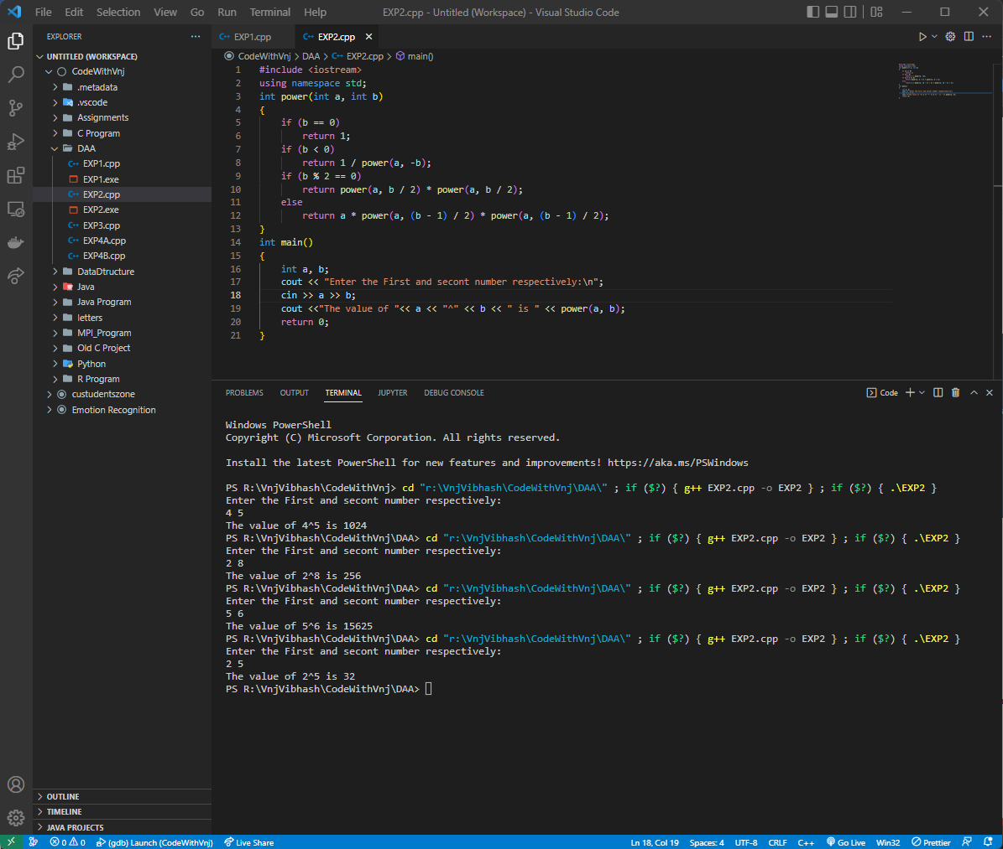

**Learning outcomes (What I have learnt):**

1. How to find the Power of any number.
2. How to Use recursive function.
3. How to achieve the O (log n) complexity.

**Evaluation Grid (To be created per the faculty's SOP and Assessment guidelines):**

|  |  |  |  |
| --- | --- | --- | --- |
| Sr. No. | Parameters | Marks Obtained | Maximum Marks |
| 1. | Worksheet completion including writing learning objectives/Outcomes.  (To be submitted at the end of the day). |  |  |
| 2. | Post-Lab Quiz Result. |  |  |
| 3. | Student Engagement in  Simulation/Demonstration/Performance and Controls/Pre-Lab Questions. |  |  |
|  | Signature of Faculty (with Date): | Total Marks Obtained: |  |